**Name: ___**_______________

**Lab 6 Exercise due on Sunday, 12:00 NOON**

**Problem Description (the same as lab 4)**

In lab 2, we have modeled a database for SUAirways to track planes and flights. In this lab, assume we created the following ERD model for the Airways database (see below).



As the model shows: the company has many airplanes which are of different specifications (e.g. Boeing 777, Airbus A320, and so on). Each aircraft specification has the same attributes, such as aircraftVersion, cabin number of seats and fuel capacity. The airplanes are assigned to diverse flight routes. Each flight route has a unique flight number, departs and arrives at particular airports at different cities in scheduled time. Every day the airplanes work according to their flight routes, but the flight schedule may be affected by flight statuses (on time, delay, or cancelled).

**Instruction**

Imagine you are hired to design a new database to support this system. In lab 5 you have created and populated the tables. Now you need to make a few changes to the table structure. You also need to write queries to answer some data questions. Please write SQL statements to finish the following tasks:

1. Alter table “AircraftSpecs” to add one more columns for number of cabins. Name the column as “cabinNumber”. The column data type is INT, and it can be null.

Alter

ALTER TABLE table_name  
ADD column_name datatype

1. Update information in table “AircraftSpecs”. For planes whose “fuelCapacity” is 63705, change their “fuelCapacity” to be 73705.

UPDATE *table_name*  
SET *column1*=*value1*,*column2*=*value2*,...  
WHERE *some_column*=*some_value*;

1. Simple data questions
2. Find out all flight schedule information of flight “3310”. Make sure to show all the fields.

SELECT *

FROM *table_name*

WHERE XXX = 3310

1. Find all flights departing from LAX airport. Show flight number, arrival airport, and depart time.

SELECT flight number, arrival airport, and depart time

FROM XXX

WHERE yyy LIKE 'zzz';

1. Find all planes purchased in March 2013. Show airplane ID and purchase date only.
2. Find all flights that are of status “Delay”. Show flight number, flight date, and delay arrive time only.
3. Find all aircraft types whose number of seats is less than 250. Show aircraft version only.
4. Use aggregate functions to answer data questions
5. Count the number of flights departing each day. Show the date and the number of flights.

SELECT COUNT(productID) as totals

FROM orderline

WHERE orderID=1004;

b) Sort AircraftSpecs table by fuel capacity in ascending order. Show the result with aircraft version and fuel capacity.

c) Calculate the average, min, and max value of cabin seats numbers for aircraft spec. Show average seat numbers, min seat numbers, and max seat numbers.

d) Show the average fuel capacity of airplanes from Boeing and Airbus separately.

**Hint:** airplanes who’s created by Airbus has a aircraftType ID starting with “AIR”, while Boeing’s aircrafts’ aircraftTypeID starting with “BOE”.

1. Open ended Questions:

From the given ERD, draft and then answer **two data questions** that you consider yield significant results. The only requirement for the query that you write for your data question is that it has to have **GROUP BY** clause as part of it. You can also choose from one of the aggregate functions such as **SUM, COUNT, AVG** or other functions thought in class.

SELECT column_name, aggregate_function(column_name)  
FROM table_name  
WHERE column_name operator value  
GROUP BY column_name;

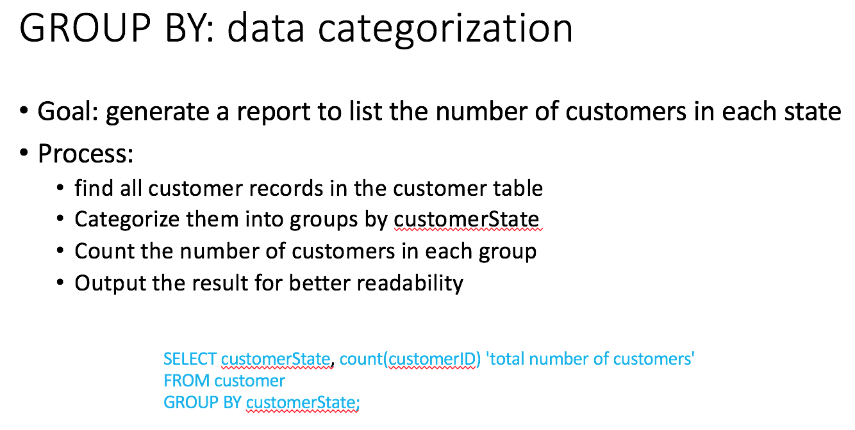

Remember to first write your data question in plain English and then write the SQL query and execute the same. Paste screenshots of the Query with the result.

**Submission instruction**

Please submit your lab report in **one** **PDF** file to BlackBoard. Name your file in this format “IST659-Lab6-Lastname-Firstname.pdf”.

After each question, copy and paste your SQL statement, followed by the screenshot to show that your SQL statement has been successfully executed. Remember to add comments to your SQL statements to explain the purpose of the code blocks.

**Due date**

The lab report is due on **Sunday, Noon**